

Communications: User Guide

Updated September 02, 2021
DCN Comms-UG-007
Version 1.0

Table of Contents
FranchiCzar OS: [Module Name] 3
What is/are [Module]? 3
Why Should I use [Module]? 3
Getting Started 3
[Module Name] 3
[Adjective of Modules action e.g. Adding, Creating, etc.] 3
[Brief title for task, e.g. “Add to Dashboard”] 3
Version History Table 5
Appendix A 6

FranchiCzar OS: Communications

What are FCOS Communications?
[Description of the module in a general way and then provide how this module works within FCOS.]

Why Should I use FCOS Communications?
[Brief description of how the use or addition of the module assist in the day-to-day use of FCOS and/or benefit to operations.]

Getting Started
[Brief description of what the module provides to the user.]

Communications
You can communicate directly with Franchisors, Franchisees, Customers, Facilities, Alliances, and their Leads of each of these modules directly from FCOS.

There are three primary modes of communication available via FCOS:
- Email 
- Phone Call 
- Text Message 

After you create a new entry within “Franchisors”, “Franchisees”, “Customers”, “Facilities”, “Alliances”, and/or their “Leads”, select the “entry” (from the navigation list) to open their “General Information” page.

Sending Emails
In the top-center of the “General Information” page is a quick actions bar.


Click the Email icon , to create a new email.

Composing Email
From the email pane, edit/select all the fields appropriate for your email and click Send.
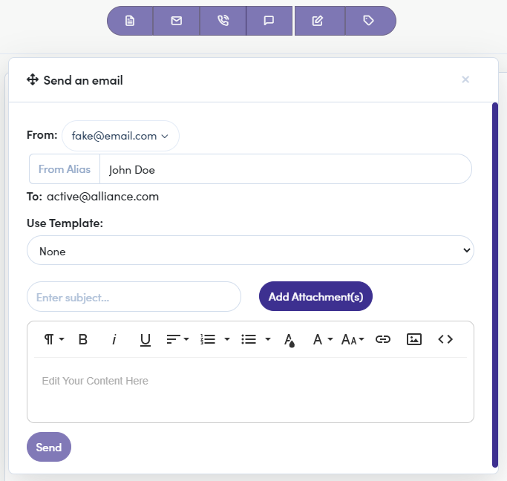


You can “Use [a] Template” previously created or compose a unique email.

Making a Call
In the top-center of the “General Information” page is a quick actions bar.


Click the Phone icon , to initiate a new phone call.

Calling Options
Clicking on the Phone icon expands a menu with two options:
- Call from Computer
- Add a Phone Number

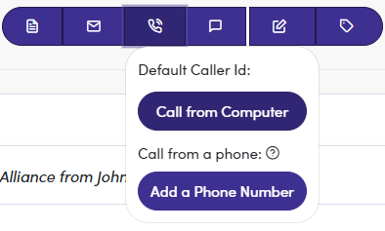

Calling from Computer
Clicking Call from [your] Computer immediately initiates a phone call using a “Default Caller Id” generated from your profile’s information.

Within the calling pane, you can write notes and when the call is completed you must select a general Call Result from a drop-down:
- Busy
- No answer
- Left voicemail
- Wrong Number
- Successful call

This information is then saved to the contact’s profile and is accessible for reviews and follow-ups.
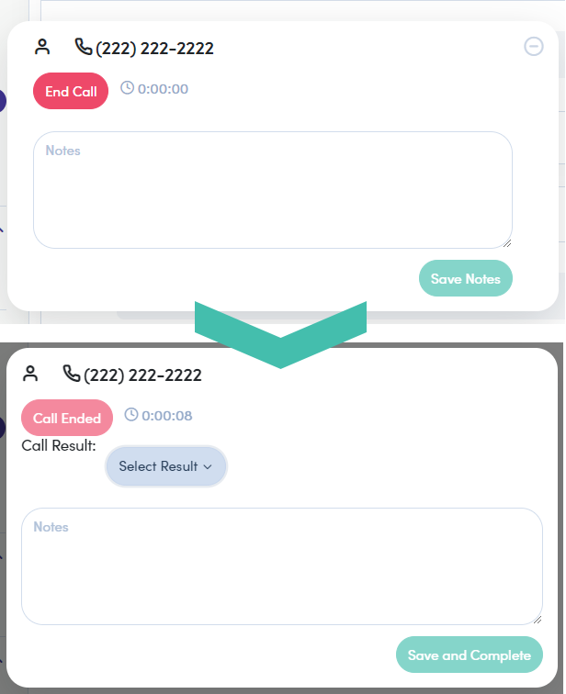

Call Using Phone #
Clicking the Add a Phone Number option expands to provide three options:
- Label – Indicates the information that appears within Caller Id
- Number – Indicates the phone number you are placing the call through
- Set as Default Caller Id – Indicates that the information provided is how you would like your calls to appear

After providing this information, click the Phone icon again and you are now able to place calls using the phone number provided (see image below).
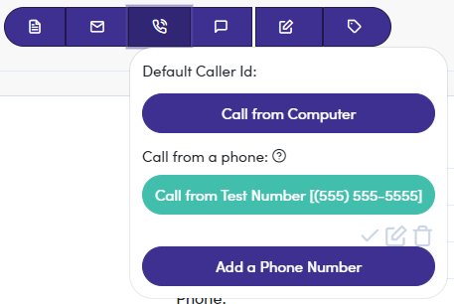

Sending Text Messages
In the top-center of the “General Information” page is a quick actions bar.


Click the Text Message icon , to initiate text messaging with your contact.

Texting Window
Clicking the “Text Message” icon launches a text communication window (bottom-right of screen).


The Text Message window floats in its position, even when clicking into a new link within FCOS.

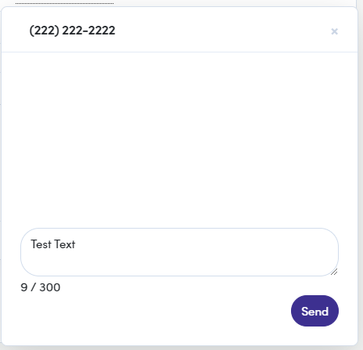

Version History Table
Date | Version | Description | Owner | Approver
07/21/2021 | 1.0 | Document template created | John Beatty

Appendix A

[Use to provide “Note”]

